Soc101 – phishing mail Detected
task ID -8
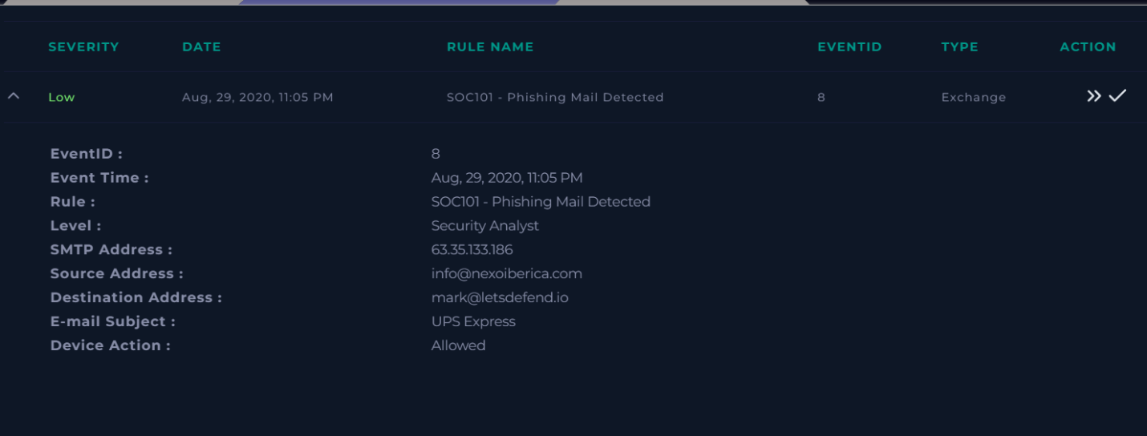

Incident Overview:
Email Details
SMTP Address: 63.35.133.186
Sender Address: info@nexoiberica.com
Recipient Address: mark@letsdefend.io

Email Subject: UPS Express
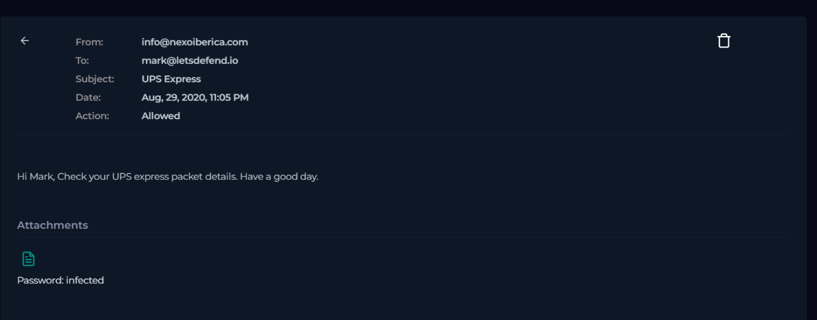

The email body contained minimal text intended to appear legitimate and non-suspicious:
“Hi Mark, Check your UPS express packet details. Have a good day.”
The message included a password-protected attachment and a download link, a common technique used by threat actors to bypass email security scanning.
Attachment password displayed within the email:
Password: infected
Malicious URL Analysis
Identified Malicious Download URL
https://download.cyberlearn.academy/download/download?url=https://files-ld.s3.us-east-2.amazonaws.com/21b3a9b03027779dc3070481a468b211.zip
Threat Intelligence Results
- Detection Ratio: 8 / 97 security vendors
- Verdict: Malware
- Content Type: text/html
- HTTP Status: 200 OK
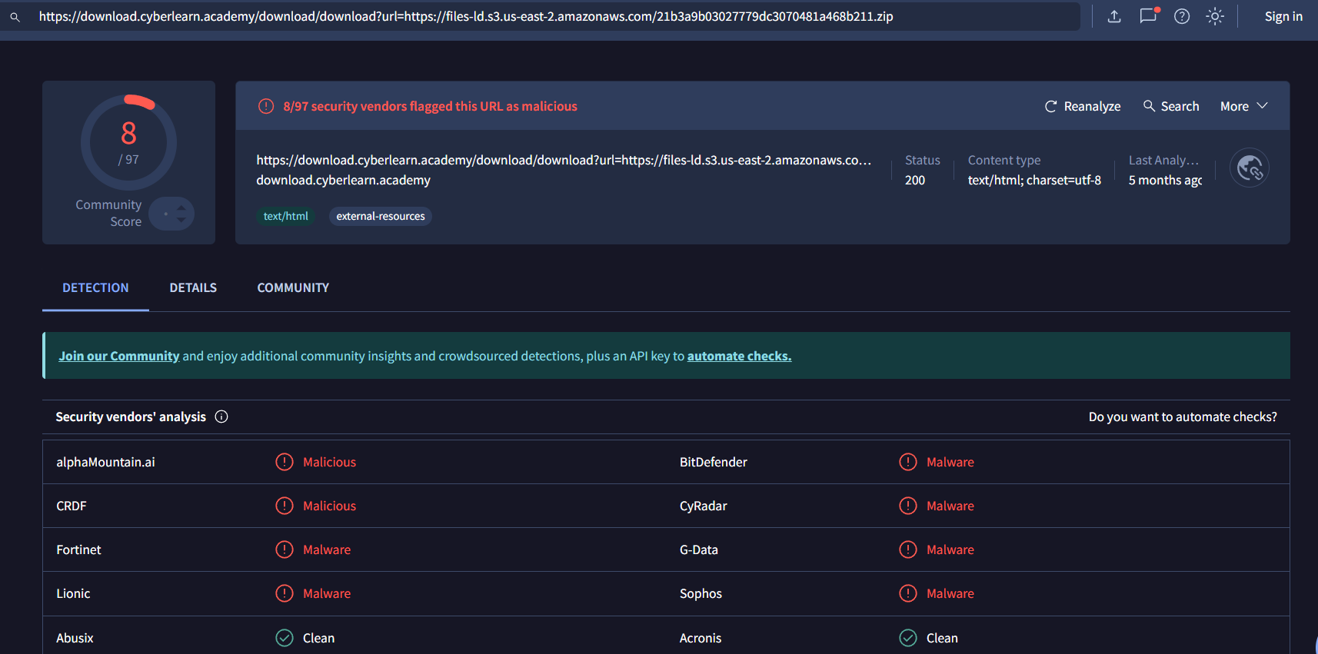
Multiple security vendors including BitDefender, Fortinet, Sophos, CyRadar, and G-Data flagged the URL as malicious.

Malware File Analysis
Extracted File Hash (SHA-256)
7dc9821a27cbc29bddb4bb3c708aad0b24a82d9bcb1a2df9cacabf7ca6bd8c06
Additional Payload Hosting
https://files-ld.s3.us-east-2.amazonaws.com/goose_goose_duck_free.rar
Threat intelligence indicates association with SilentBuilder malware, a known dropper and downloader commonly used to deliver secondary payloads.

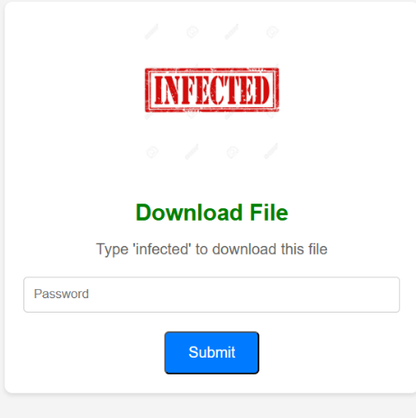

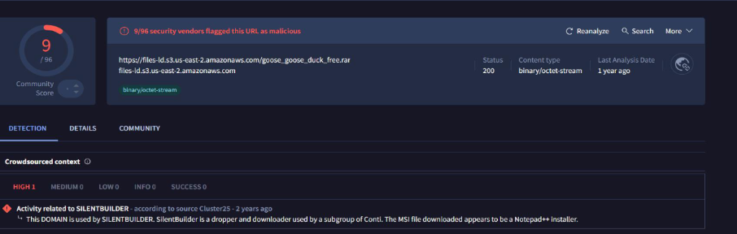

Endpoint Telemetry Review
Endpoint visibility confirmed that the email was delivered; however:
- No confirmed malware execution was observed
- No confirmed command-and-control traffic detected
- No persistence mechanisms identified
EDR timeline showed limited activity associated with the downloaded file.
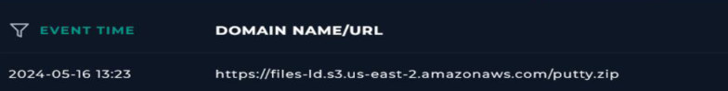
Investigation Questions :
When was it sent? Aug 29, 2020, 11:05 PM
• What is the email’s SMTP address? 63.35.133.186
• What is the sender address? info@nexoiberica.com
• What is the recipient address? mark@letsdefend.io
• Is the mail content suspicious? Yes
• Are there any attachments? Yes
